

Q-Learning Management System
User manual

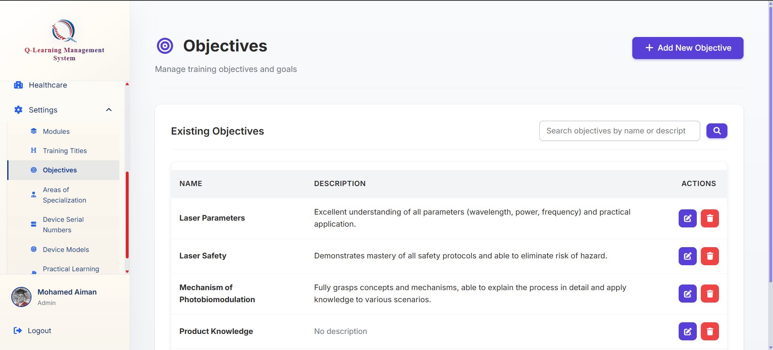
How to add a new Objective
Click on the add Objective button

Go ahead to the Objective tab at the bottom of the sidebar
These objectives would be used by the system when creating the questions later in the question bank



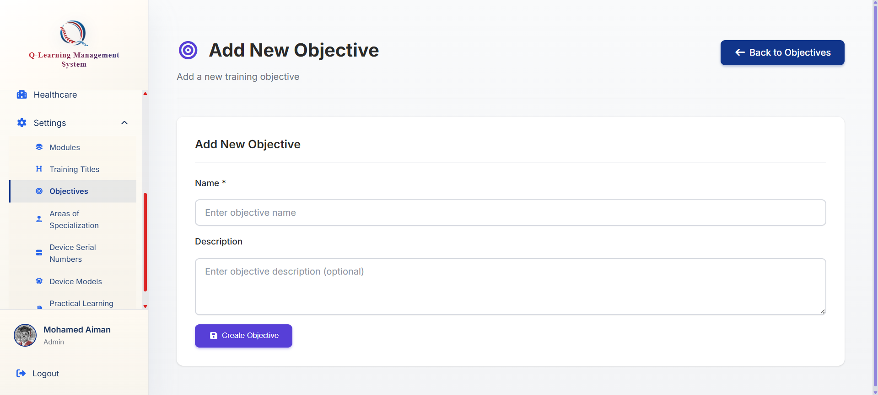
You will be brought to this form where you may fill up the details needed
Click on this button to submit and create

